FACULTY PROFILE
Name of the Faculty | : | Dr. A. SURESH KUMAR | 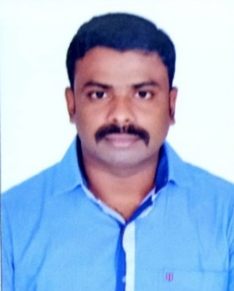
Date of Birth | : | 31-12-1985
Designation | : | Professor & Head
Department | : | Civil Engineering
Qualification | : | M.E., Ph.D.
Date of Joining | : | 01-11-2022
Total Teaching Experience | : | 14
Total Industry Experience | : | 1.3
Address | : | 1A3, Sai Galaxy, SRIET College Backside, Athipalayam, Coimbatore - 641110
Educational Qualification
Course | Institution | University | Year of Passing
Ph.D. | Kalasalingam Academy of Research and Education | KARE | 2022
M.E.(Structural) | MEPCO Schlenk Engineering College | Anna University, Thirunelveli | 2010
B.E (Civil) | Raja College of Engineering and Technology | Anna University, Chennai | 2007
HSC | SEV Matriculation Higher Secondary School | State Board | 2003
SSLC | SEV Matriculation Higher Secondary School | State Board | 2001
Achievement:
S.no | Category | No of Publications
1 | Patent | 8
2 | National & International Conference | 6
3 | Journal Publication | 36
4 | No of FDPs Attended | 32
5 | No of Workshops Attended | 10
6 | No of Webinars Attended | 15
7 | Faculty Membership in Professional Bodies | 1
8 | NPTEL Online Course | 1

FACULTY PROFILE
Name of the Faculty | : | U. NANDHINI | 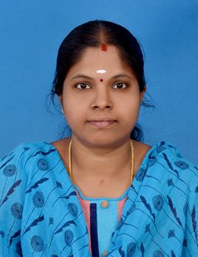
Date of Birth | : | 27-05-1992
Designation | : | Assistant Professor
Department | : | Civil Engineering
Qualification | : | M.E., (Ph. D).,
Date of Joining | : | 7.7.2021
Total Teaching Experience | : | 5.8 Years
Total Industry Experience | : | -
Address | : | 1a2,Sai Galaxy, Athipalayam, Coimbatore
Educational Qualification
Course | Institution | University | Year of Passing
Ph.D. | Anna University | Anna University | Pursuing
Cyber security & digital Forensic | IIIT Kottayam | IIT | 2025
M.E.(Structural) | SBM College of Engg.& Tech. | Anna University | 2017
B.E (Civil) | RVS College of Engg.& Tech | Anna University | 2013
HSC | Periyar Maniammai Girls Hr.Sec.School | State Board | 2009
SSLC | Periyar Maniammai Girls Hr.Sec.School | State Board | 2007
Achievement:
S.no | Category | No of Publications
1 | Patent | 1
2 | National & International Conference | 2
3 | Journal Publication | 1
4 | No of FDPs Attended | 30
5 | No of Workshops Attended | 5
6 | No of Webinars Attended | 20
7 | Faculty Membership in Professional Bodies | 1
8 | NPTEL Online Course | 4

FACULTY PROFILE
Name of the Faculty | : | K VIJAY SANKAR | 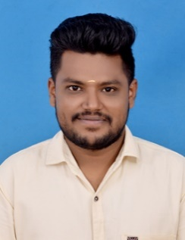
Date of Birth | : | 12-07-1996
Designation | : | Assistant Professor
Department | : | Civil Engineering
Qualification | : | M.E., (Ph.D.)
Date of Joining | : | 01-03-2022
Total Teaching Experience | : | 6.2 years
Total Industry Experience | : | -
Address | : | 1/74B Annai Nagar 3rd Street, Ponnagaram, Nagal Nagar(Po), Dindigul-624003
Educational Qualification
Course | Institution | University | Year of Passing
Ph.D. | Anna University | Anna University | Pursuing
M.E.(Structural) | PSNA College of Engineering and Technology | Anna University | 2019
B.E (Civil) | Loyola Institute of Engineering and Technology | Anna University | 2017
HSC | MSP Solai Nadar Memorial Higher Secondary School | State Board | 2013
SSLC | MSP Solai Nadar Memorial Higher Secondary School | State Board | 2011
Achievement:
S.no | Category | No of Publications
1 | Patent | 15
2 | National & International Conference | 14
3 | Journal Publication | 13
4 | No of FDPs Attended | 50
5 | No of Workshops Attended | 03
6 | No of Webinars Attended | 32
7 | Faculty Membership in Professional Bodies | 2
8 | NPTEL Online Course | 4

FACULTY PROFILE
Name of the Faculty | : | S. PREAM KUMAR | 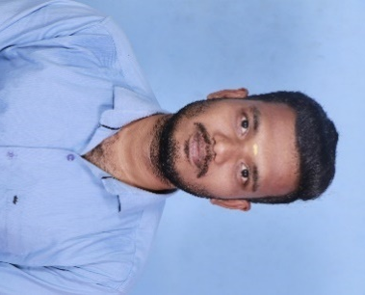
Date of Birth | : | 24/09/1997
Designation | : | Assistant Professor
Department | : | Civil Engineering
Qualification | : | M.Tech, (Ph.D).,
Date of Joining | : | 06.07.2022
Total Teaching Experience | : | 3.6Years
Total Industry Experience | : | 1.1 Years
Address | : | 208/5, SRV Nagar, Thirunagar, Madurai – 625006.
Educational Qualification
Course | Institution | University | Year of Passing
Ph.D. | Vel Tech Rangarajan Dr. Sagunthala R&D Institute of Science and Technology | Deemed to be University | Pursuing
M.Tech.(Structural) | Kalasalingam Academy of Research and education. | Deemed to be University | 2022
B.Tech. (Civil) | Kalasalingam Academy of Research and education. | Deemed to be University | 2019
HSC | Vaigai Matric Hr. Sec, School | State Board | 2015
SSLC | Amrita Vidyalayam | State Board | 2013
Achievement:
S.no | Category | No of Publications
1 | Patent | 15
2 | National & International Conference | 14
3 | Journal Publication | 15
4 | No of FDPs Attended | 43
5 | No of Workshops Attended | 03
6 | No of Webinars Attended | 28
7 | Faculty Membership in Professional Bodies | 1
8 | NPTEL Online Course | 4

FACULTY PROFILE
Name of the Faculty | : | M. PRIYANKA | 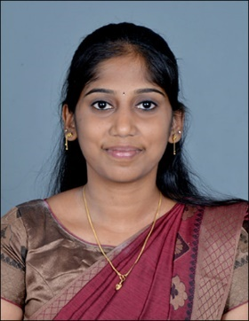
Date of Birth | : | 13-03-2000
Designation | : | Assistant Professor
Department | : | Civil Engineering
Qualification | : | M.E.,
Date of Joining | : | 03/07/2023
Total Teaching Experience | : | 2.6 Months
Total Industry Experience | : | -
Address | : | 6/20, Main Road, Vaiyampalayam, Coimbatore- 641110
Educational Qualification
Course | Institution | University | Year of Passing
M.E.(Structural) | Kumaraguru College of Technology | Anna University | 2023
B.E (Civil) | Sri Ranganathar Institute of Engineering and Technology | Anna University | 2021
HSC | Vidyaa Vikas Matriculation Higher secondary school | State Board | 2017
SSLC | Vidyaa Vikas Matriculation Higher secondary school | State Board | 2015
Achievement:
S.no | Category | No of Publications
1 | Patent | 2
2 | National & International Conference | 2
3 | Journal Publication | 3
4 | No of FDPs Attended | 25
5 | No of Workshops Attended | 5
6 | No of Webinars Attended | 32
7 | Faculty Membership in Professional Bodies | 1
8 | NPTEL Online Course | 2

FACULTY PROFILE
Name of the Faculty | : | M P MEERA | 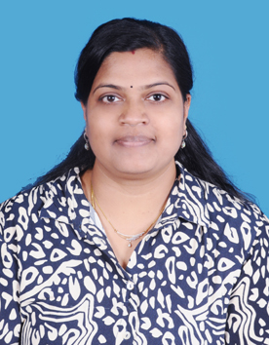
Date of Birth | : | 15-05-1988
Designation | : | Assistant Professor
Department | : | Civil Engineering
Qualification | : | M.E., (Ph. D).,
Date of Joining | : | 10.7.2023
Total Teaching Experience | : | 6.2 Years
Total Industry Experience | : | 7.5 Years
Address | : | 131, Kattabomman street, Ganapathy, Coimbatore.
Educational Qualification
Course | Institution | University | Year of Passing
Ph.D. | Anna University | Anna University | Pursuing
Cyber security & digital Forensic | IIIT Kottayam | IIT | 2025
M.E.(Structural) | SNS College of Technology | Anna University | 2019
B.E (Civil) | Al-Ameen Engineering College | Calicut University | 2009
HSC | HSS Vallappuzha, Kerala | State Board | 2006
SSLC | GVHSS Koppam, Kerala | State Board | 2004
Achievement:
S.no | Category | No of Publications
1 | Patent | 5
2 | National & International Conference | 4
3 | Journal Publication | 2
4 | No of FDPs Attended | 25
5 | No of Workshops Attended | 5
6 | No of Webinars Attended | 38
7 | Faculty Membership in Professional Bodies | 1
8 | NPTEL Online Course | 4

FACULTY PROFILE
Name of the Faculty | : | K ASWINKUMAR | 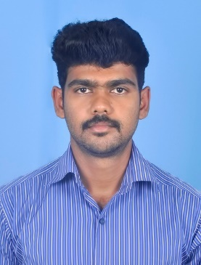
Date of Birth | : | 22-03-1996
Designation | : | Assistant Professor
Department | : | Civil Engineering
Qualification | : | M.E.,
Date of Joining | : | 02-05-2024
Total Teaching Experience | : | 4.2 years
Total Industry Experience | : | 1.5 years
Address | : | 44/35, B /12 Kullanampatti, Natham Road, Dindigul-624003
Educational Qualification
Course | Institution | University | Year of Passing
M.E.(Structural) | PSNA College of Engineering and Technology | Anna University | 2019
B.E (Civil) | VSB College of Engineering Technical campus | Anna University | 2017
HSC | Achyuta academy Matriculation Higher Secondary School | State Board | 2013
SSLC | Vidhya Parthi Higher Secondary School | State Board | 2011
Achievement:
S.no | Category | No of Publications
1 | Patent | 2
2 | National & International Conference | 2
3 | Journal Publication | -
4 | No of FDPs Attended | 10
5 | No of Workshops Attended | 2
6 | No of Webinars Attended | 18
7 | Faculty Membership in Professional Bodies | -
8 | NPTEL Online Course | 1

FACULTY PROFILE
Name of the Faculty | : | C.LATHIGA | 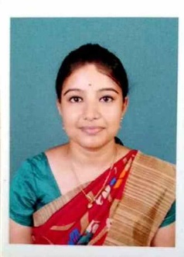
Date of Birth | : | 30-11-1993
Designation | : | Assistant Professor
Department | : | Civil Engineering
Qualification | : | M.E.,
Date of Joining | : | 23.08.2021
Total Teaching Experience | : | 7.4 Years
Total Industry Experience | : | -
Address | : | 7/10 – 1, 2 LIC COLONY, NO 4 VEERAPANDI PIRIVU, COIMBATORE -641019
Educational Qualification
Course | Institution | University | Year of Passing
M.E.(Environmental) | COIMBATORE INSTITUTE OF TECHNOLOGY | Anna university | 2017
B.E (Civil) | INFO INSTITUTE OF ENGINEERING | Anna university | 2015
Achievement:
S.no | Category | No of Publications
1 | Patent | -
2 | National & International Conference | -
3 | Journal Publication | -
4 | No of FDPs Attended | 3
5 | No of Workshops Attended | -
6 | No of Webinars Attended | 10
7 | Faculty Membership in Professional Bodies | -
8 | NPTEL Online Course | -

FACULTY PROFILE
Name of the Faculty | : | A SRINISHA | 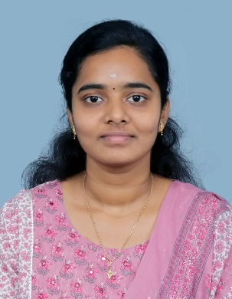
Date of Birth | : | 26.09.1996
Designation | : | Assistant Professor
Department | : | Civil Engineering
Qualification | : | M.E., (Ph. D).,
Date of Joining | : | 23.06.2025
Total Teaching Experience | : | 3.5 Years
Total Industry Experience | : | -
Address | : | 2/53A Middle Street, Athiplayam, Coimbatore-641110
Educational Qualification
Course | Institution | University | Year of Passing
Ph.D. | Anna University | Anna University | Pursuing
M.E.(Environmental Engineering) | Anna University Regional Campus, Tirunelveli | Anna University | 2020
B.E (Civil) | Info Institute of Engineering | Anna University | 2018
HSC | Vidya vikashini Matric. Hr Sec School | Matriculation | 2014
SSLC | Kendria Vidyalaya | CBSE | 2012
Achievement:
S.no | Category | No of Publications
1 | Patent | 1
2 | National & International Conference | 1
3 | Journal Publication | 3
4 | No of FDPs Attended | 15
5 | No of Workshops Attended | 2
6 | No of Webinars Attended | 20
7 | Faculty Membership in Professional Bodies | 1
8 | NPTEL Online Course | 8

